Assignment 1 | Part 1

Team : akushwah-anekkal-kngiri-shfadn

# calculating the magnitude.

In section 1.1. we calculated magnitude by using imaginary and real values generated by the fft().

As you can see we are simply returning the magnitude. Which can be leveraged in other sections in the Assignment part 1 for calculating the fft_magnitude.

# Removing Noise

In this section, the task is to remove noise from the image provided by the professor. Below is the sample image provided by the professor.

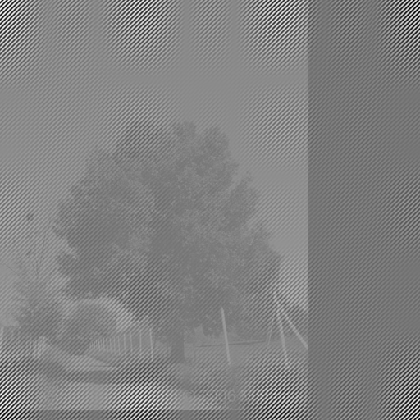 

*Fig. noisy image provided by the professor. Fig. Spectrogram of the noisy image.*

In the spectrogram, we have observed the keyword **HI** which has been introduced into the fft space symmetrically from the origin.

### Removing “HI” from Spectrogram which is placed symmetrically across the origin in fft space.

We have removed HI from fft space by replacing the entire HI Space gird with ‘0’s. Below is the figure which clearly explains what we have achieved.

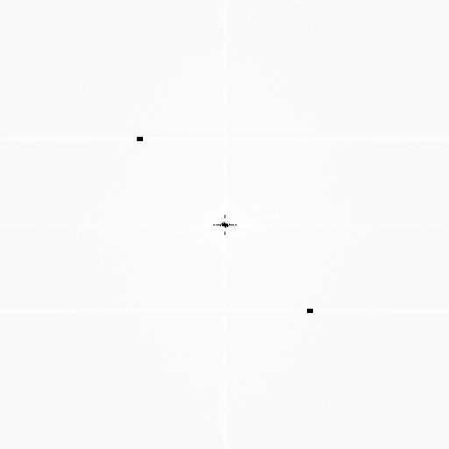

Now we have used the updated real values and imaginary values to generate the image.

Upon doing this we got an image which has a grey transparent overlay. So, we continued doing further modifications to the image as shown in the below image as follows.

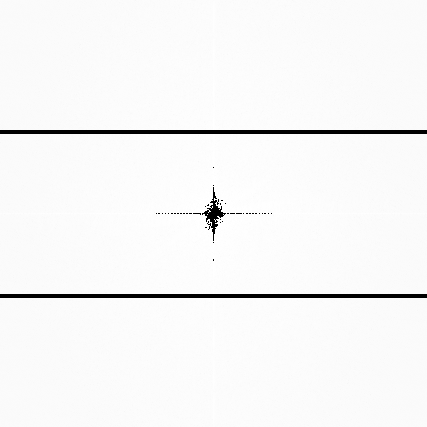

*Fig. Final Image spectrum of the after all the changes.*

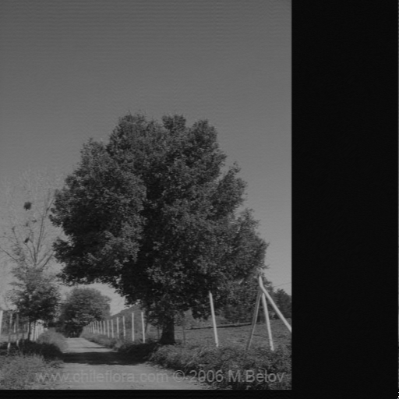

*Fig. Final Image after all the changes.*

# Water marking an image

In this section, we have applied the watermark using the Fourier transform. Below are the steps that we have used:

To apply the watermark:

1. We took the image first found that is it square or not. If not, we added the padding pixels to the plane and then copied each pixel to the new plane.
2. To create a watermark, we used a vector of 16-bit long.
3. We took the real value and applied the formula by combining the alpha and absolute value to get the watermark in the specified circular pattern.
4. When everything was done, we combined the new real values with the imaginary to form our image with the watermark into it.

To check for the watermark:

1. The watermarked image was passed as the parameter and the real value was extracted in the same circular way as it was injected.

**Challenges:**

1. We started with 8 bits with the values far apart at the corners in circular pattern. This gave us the correlation value of zero efficiency. So, the first tweak in parameter came in by increasing the bits to 16-bit and reducing the area of circle to 1/8th of the radius. This gave us a better correlation in compared to the previous one.
2. What value of alpha will be the best as some give a good high in the spectrogram but blurs the image which is difficult to view.
3. Creating a circular pattern was also one of the challenge. Finding the points keeping the symmetry was one of a task.

**Observations:**

Qualitative Observation:

To show how we are injecting the watermark. Below are the images (Visible circular pattern) which shows that the watermark was present and it did survive. This was the spectrogram that was generated in 3-D for a better view of the spectrum

Image 1:





Quantitative Analysis:

We tested every image for 50 random value and while 80% of times it found the correct watermark but for the rest 20% of times it gave the false positive answers too. We tried our best to tweak the values and fit in the best parameters that we can.